Additional Exercises 11

Finding validity of a tableau:

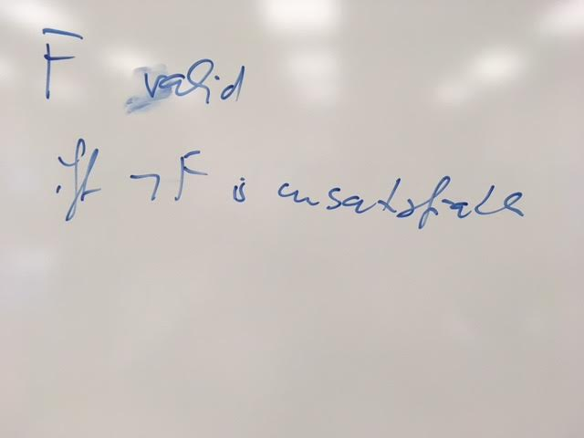

Finding satisfiability:

A tableau is satisfiable if there is a non-closed path in the tableau.

Finding unsatisfiability:

A tableau is unsatisfiable if all paths in the tableau are closed.

Finding entailment using a tableau:

(All you have to do is see whether the last line in the image holds true. If so, then it is entailed. Otherwise, it is not entailed.)

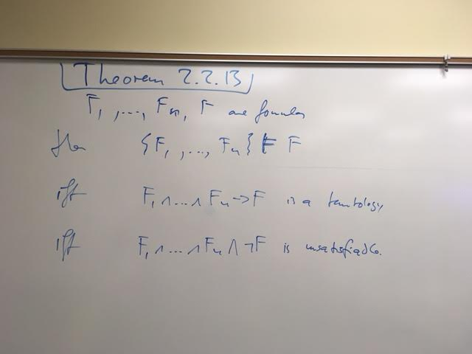

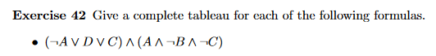

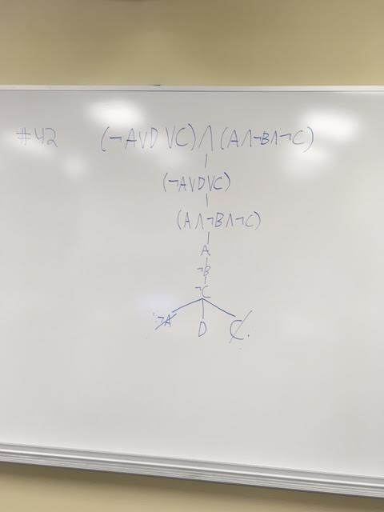







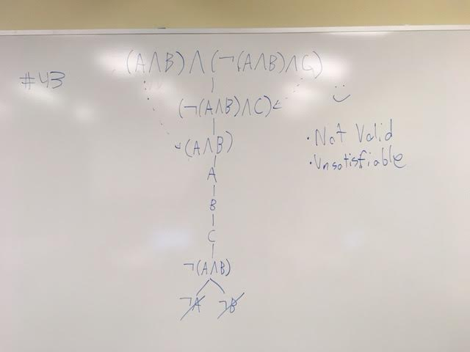



*Finding F:*

(A → ᆨB) ⋁ᆨ(A ⋀ ᆨ(B ⋀ C))

**F** ≡ **(ᆨA ⋁ ᆨB) ⋁ (ᆨA ∨ (B ⋀ C))**

*Finding ᆨF:*

ᆨ( (A → ᆨB) ⋁ᆨ(A ⋀ ᆨ(B ⋀ C)) )

ᆨ(ᆨA ⋁ ᆨB) ⋀ ᆨ(ᆨA ⋁ (B ⋀ C))

(A ⋀ B) ⋀ (A ⋀ ᆨ(B ⋀ C))

**ᆨF** ≡ **(A ⋀ B) ⋀ (A ⋀ (ᆨB ⋁ᆨC))**

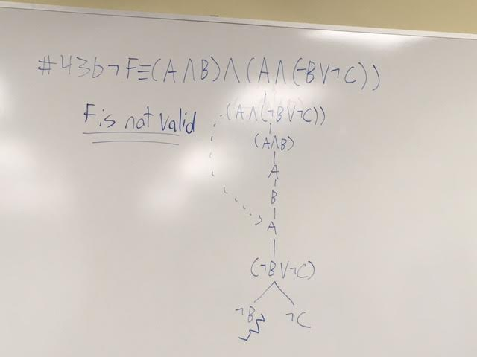





Note: use ᆨF on the right side. Connect to the main formula with an AND.

((A ∨ ᆨB ∨ C) ⋀ (B ⋀ ᆨC)) ⋀ ᆨ(A ∨ B)

((A ∨ ᆨB ∨ C) ⋀ (B ⋀ ᆨC)) ⋀ (ᆨA ⋀ ᆨB)

(A ∨ ᆨB ∨ C) ⋀ (B ⋀ ᆨC) ⋀ (ᆨA ⋀ ᆨB)

